Accenture — BI Developer
Technical Round (15 LPA)
Panel: 1 Interviewer
Duration: 50 Minutes
Q1. What is the difference between a non-clustered index and a filtered index?
Q2. How do you detect whether a SQL query plan is using parallelism, and when is it faster than serial execution?
Q3. Difference between RANKX with ALL vs RANKX with ALLSELECTED.
Q4. What is KEEPFILTERS, and when would you add it inside a CALCULATE?
Q5. Scenario: A report shows blank instead of 0 for missing categories. How do you fix it with a DAX measure?
Q6. What is a Fabric Workspace, and how do you set up workspace-level RLS?
Q7. Difference between incremental refresh and a hybrid table with a DirectQuery partition.
Q8. What is medallion architecture (Bronze/Silver/Gold), and where would you put data quality checks?
Q9. Scenario: A Lakehouse needs to ingest data from an API that sends updates hourly. Design the flow.
Q10. How do you handle calculated columns in Direct Lake without triggering a fallback?
Q11. What is a Semantic Model role (vs a traditional dataset role in Power BI)?
Q12. Difference between a star schema and a normalized schema — why do data warehouses prefer star?
Q13. Scenario: An RLS rule blocks access to a table, but the user needs to see a summary of that table. How?
Q14. What is the V-Order optimization on Delta tables, and why does it matter for Direct Lake?
Q15. How do you version-control a Fabric notebook alongside a Power BI semantic model?
Hope this helps anyone preparing for Power BI, Fabric, SQL, and Data Engineering interviews!

Tiger Analytics offered him 13 lpa for Power BI Developer role
Technical Round Panel : 2 👥
Duration 45 min
1. How do you design a scalable Power BI data model?
I follow star schema, keep fact tables lean, avoid bi-directional relationships, use proper granularity, separate measures into a dedicated table, and plan for future data growth from day one.
2. Difference between Import, DirectQuery, Composite models.
Import: Best performance, data stored in Power BI
DirectQuery: Real-time data, but slower visuals
Composite: Mix of both - used when some data needs real-time and some doesn’t
3. When do you choose star schema over snowflake?
Almost always star schema. It’s simpler, faster, easier to maintain, and performs better in Power BI compared to snowflake models.
4. How do you handle large datasets in Power BI?
Incremental refresh, aggregation tables, reducing column cardinality, optimized DAX, query folding, and sometimes DirectQuery for real-time requirements.
DAX (Advanced)
5. Difference between CALCULATE vs FILTER.
CALCULATE modifies filter context
FILTER returns a table
FILTER is often used inside CALCULATE.
6. Explain Row Context vs Filter Context.
Row context exists when iterating row-by-row (like in SUMX).
Filter context comes from slicers, visuals, or CALCULATE.
7.How does Context Transition work?
When CALCULATE is used inside a row context, it converts row context into filter context - that’s context transition.
8. DAX for YTD, MTD, QTD.
YTD Sales = TOTALYTD([Total Sales], 'Date'[Date])
MTD Sales = TOTALMTD([Total Sales], 'Date'[Date])
QTD Sales = TOTALQTD([Total Sales], 'Date'[Date])
9. Difference between ALL, ALLEXCEPT, ALLSELECTED.
ALL: Removes all filters
ALLEXCEPT: Removes filters except selected columns
ALLSELECTED: Respects slicer selections but ignores visual filters
10. Running Total DAX.
Running Total =
CALCULATE(
[Total Sales],
FILTER(
ALL('Date'),
'Date'[Date] <= MAX('Date'[Date])
)
)
11. How do you optimize slow DAX measures?
Reduce iterator usage, avoid unnecessary FILTER, use variables, check relationships, and analyze with Performance Analyzer.
12. What is SUMX and when to use it?
SUMX is an iterator - used when calculations are required row-by-row instead of a simple aggregation.
13. Explain Time Intelligence functions.
They help compare time-based metrics like YoY, MoM, YTD - and require a proper continuous date table.
14. How do you debug incorrect DAX results?
I validate intermediate steps using variables, check filter context, use simple visuals/tables, and test measures independently.
𝗙𝗼𝗿 𝗰𝗼𝗺𝗽𝗹𝗲𝘁𝗲 𝗜𝗻𝘁𝗲𝗿𝘃𝗶𝗲𝘄 𝗤𝘂𝗲𝘀𝘁𝗶𝗼𝗻 𝗯𝗮𝗻𝗸 𝗰𝗵𝗲𝗰𝗸 𝗼𝘂𝘁👇
https://lnkd.in/eCGQyKrc

🚨 Preparing for a PwC Data Engineer interview? Don’t prepare only theory.
For 2–5 YOE Data Engineer roles, interviews can go much deeper than basic SQL questions.
You may be asked to solve problems around:
🔹 SQL & problem solving
🔹 PySpark & data transformation
🔹 Azure Data Factory
🔹 Databricks & Delta Lake
🔹 Data modeling & warehousing
🔹 AWS/Azure cloud architecture
🔹 Streaming & real-time data
One question that really matters:
“Walk me through the architecture of your last data engineering project.”
A strong answer shouldn't just list tools.
Explain:
Source → Ingestion → Storage → Processing → Transformation → Serving → Monitoring
And most importantly, explain why you chose each technology and what business problem it solved.
For example:
ADF → Databricks/PySpark → ADLS → Delta Lake → Synapse/Power BI
Then add measurable impact:
📌 Reduced pipeline runtime
📌 Improved data quality
📌 Reduced cloud cost
📌 Increased reliability
📌 Handled larger data volumes
That's the difference between saying “I know Data Engineering” and showing “I have worked like a Data Engineer.”
📚 I’ve put together these PwC Data Engineer interview questions for 2–5 YOE, covering technical, scenario-based and project questions.
Save this post. Share it with someone preparing for a Data Engineer interview.
📚 Interview Preparation Resources
👉 1–4 YOE Data Engineer Pack
https://lnkd.in/gau5s8h7
👉 4–8 YOE Data Engineer Pack
https://lnkd.in/gFuBy7EV
👉 Azure Data Engineer Interview Guide 2026
https://lnkd.in/gF4_tCQj
👉 600 Real Data Engineer Interview Questions
https://lnkd.in/gvX-we8v
👉 Azure Data Engineer Company-Wise Pack (500 Questions)
https://lnkd.in/gZ4NJDzw
👉 34-Day Data Engineer Preparation Journey
https://lnkd.in/gasWuvwu
👉 Data Engineer Mega Pack (1300+ Real-Time Scenario Q&As)
https://lnkd.in/gEushWwU
What are you preparing for right now?
SQL | PySpark | ADF | Databricks | Azure | AWS
hashtag#DataEngineer hashtag#DataEngineering hashtag#PwC hashtag#PwCInterview hashtag#DataEngineerInterview hashtag#SQL hashtag#PySpark hashtag#AzureDataFactory hashtag#Databricks hashtag#DeltaLake hashtag#Azure hashtag#AWS hashtag#BigData hashtag#TechInterview hashtag#InterviewPreparation

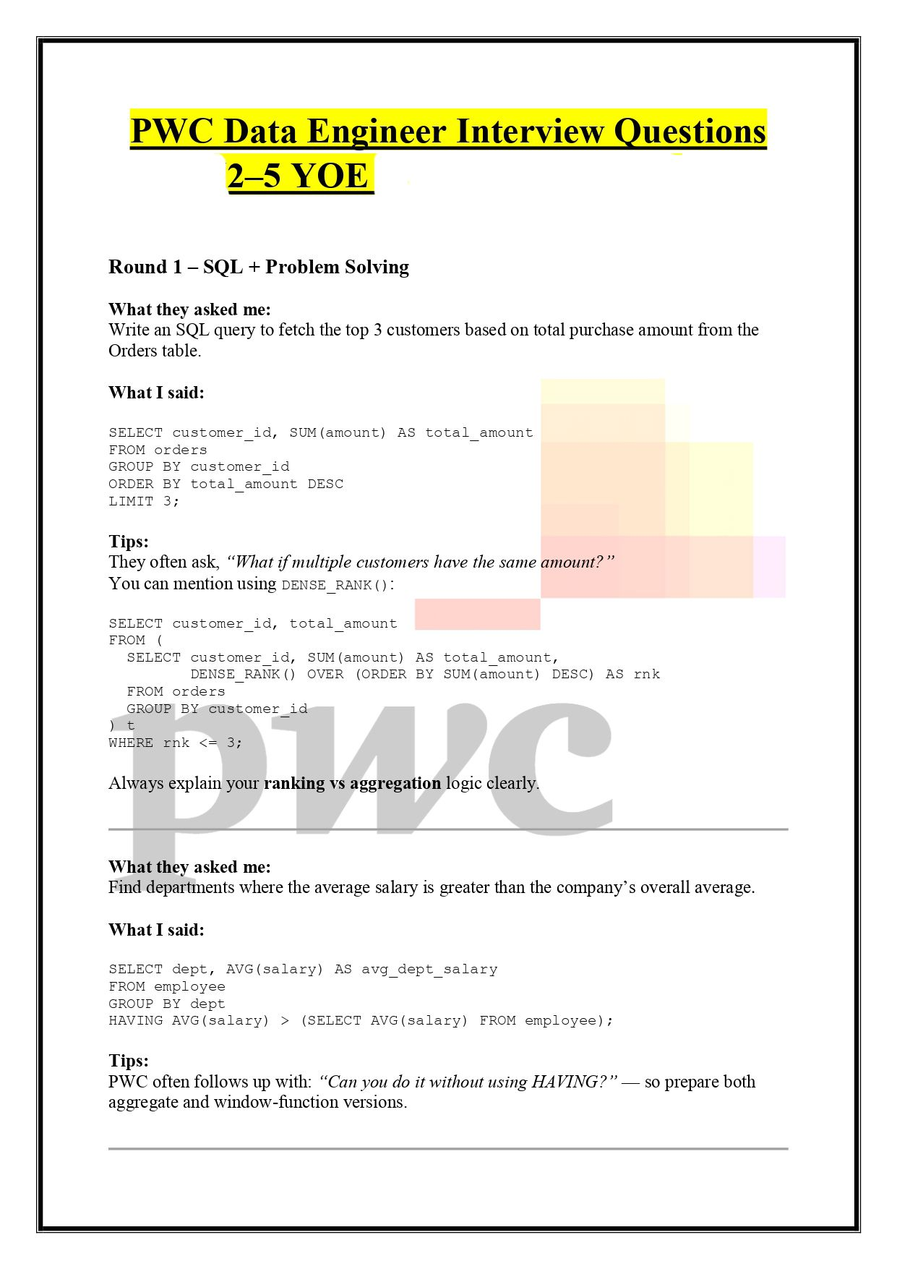

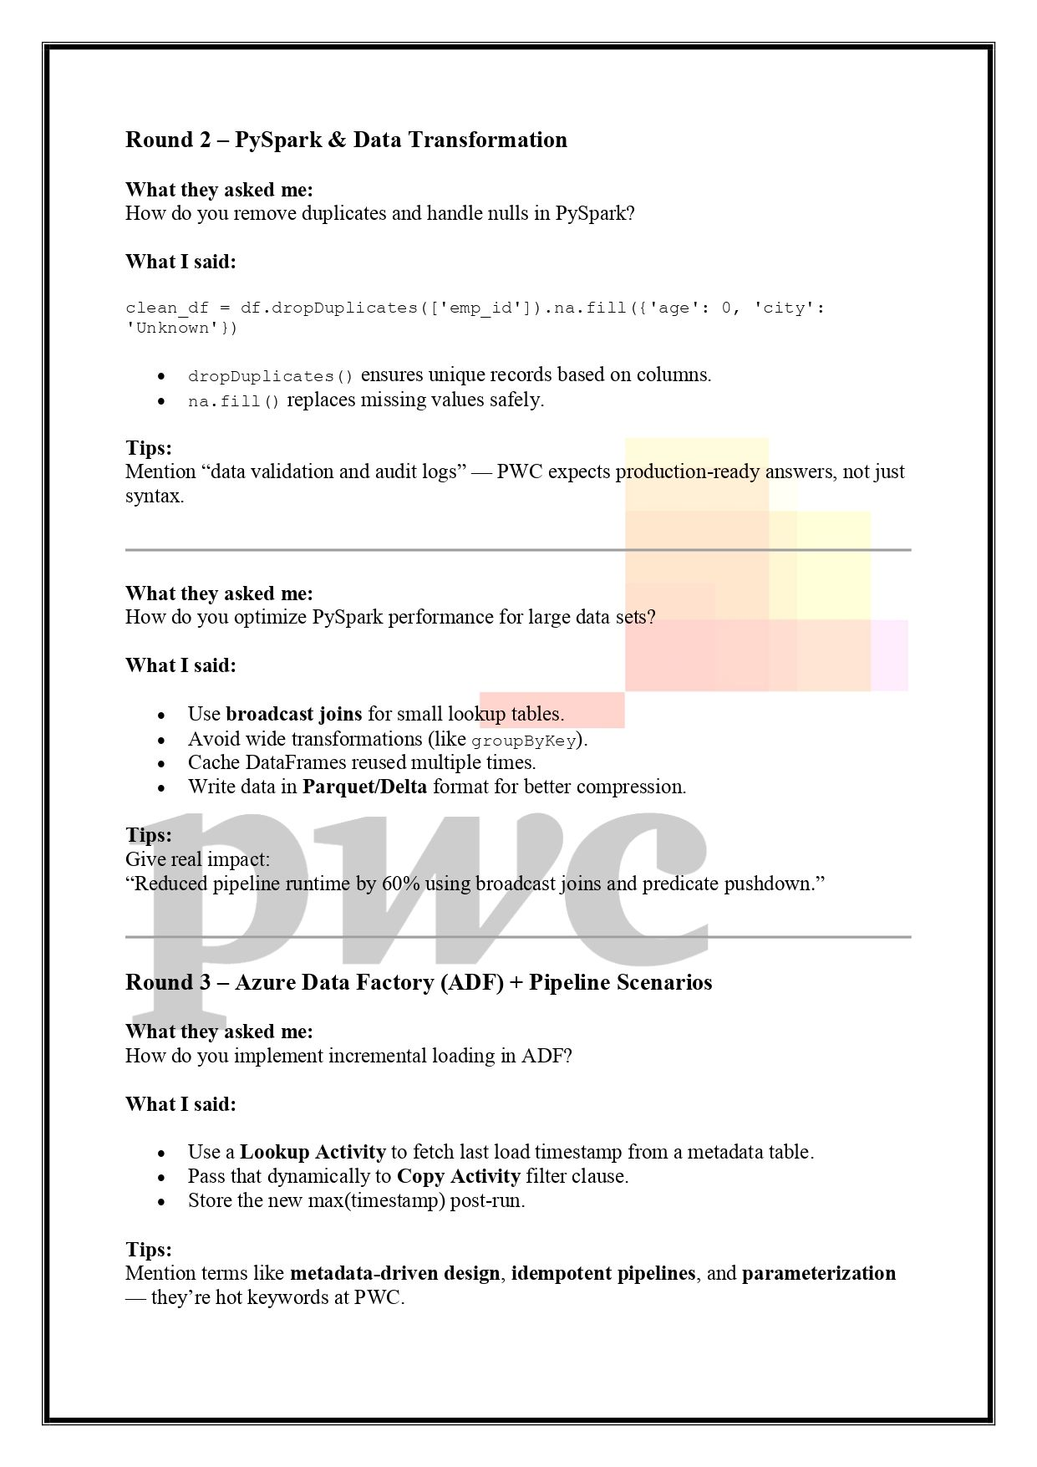

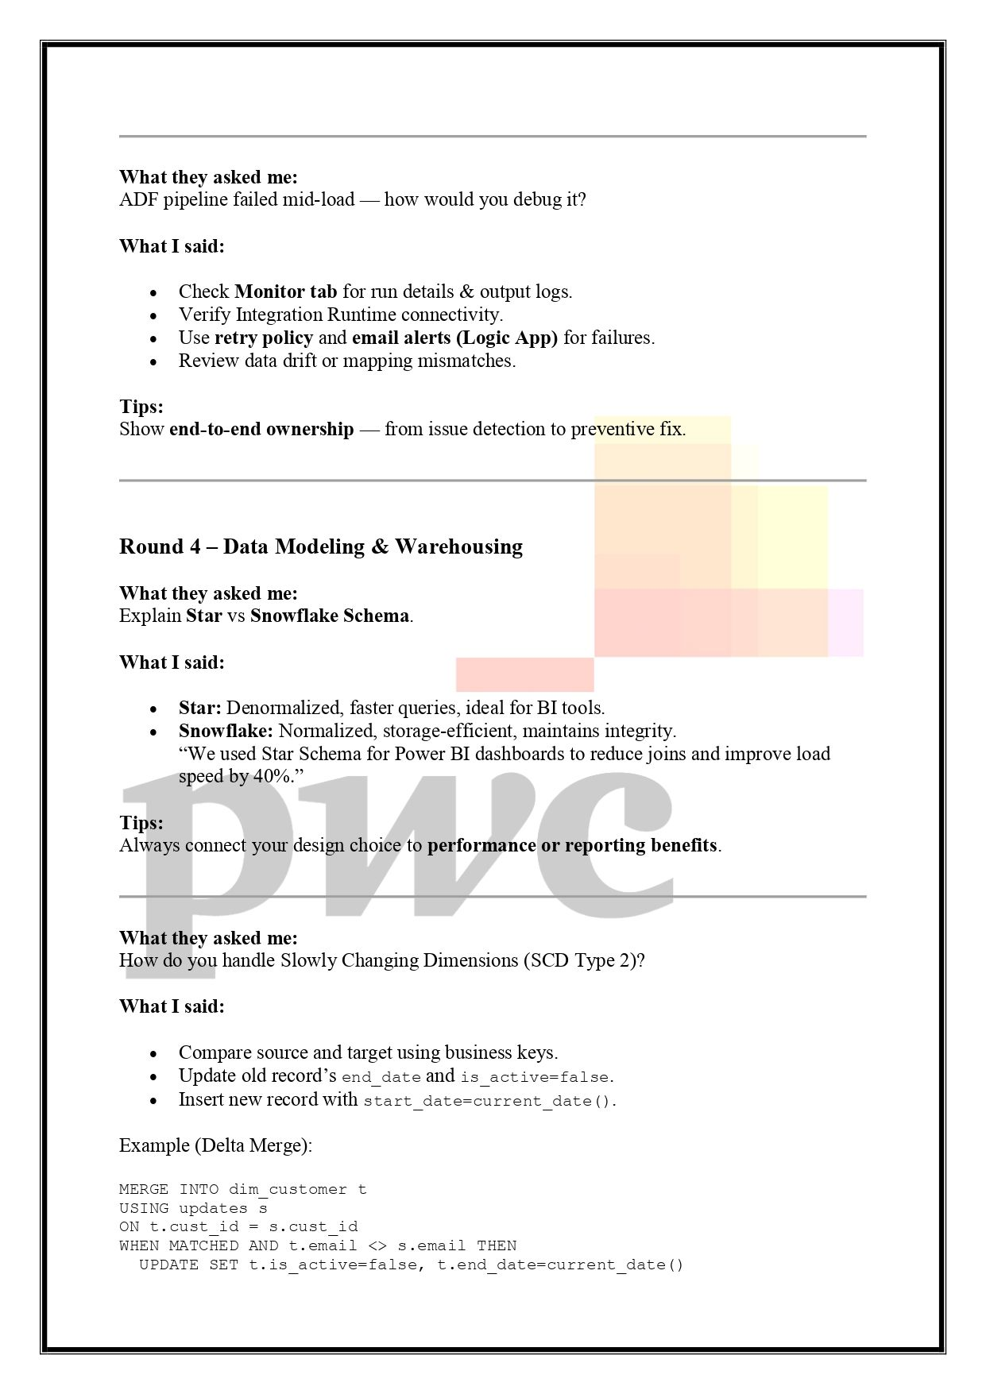

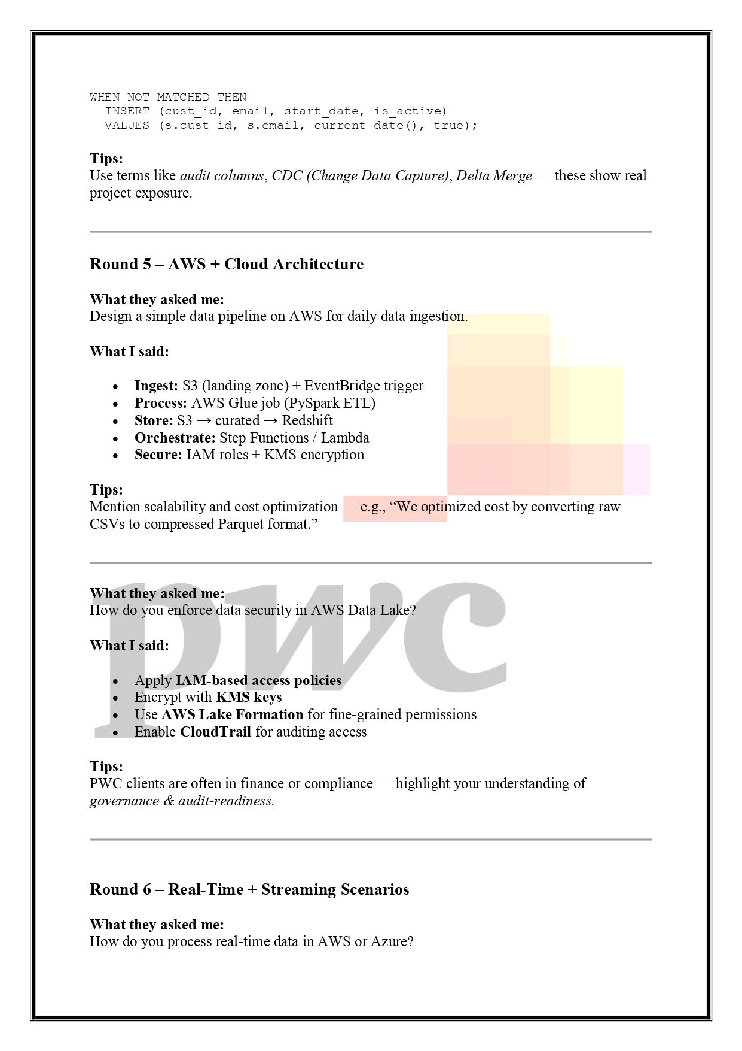

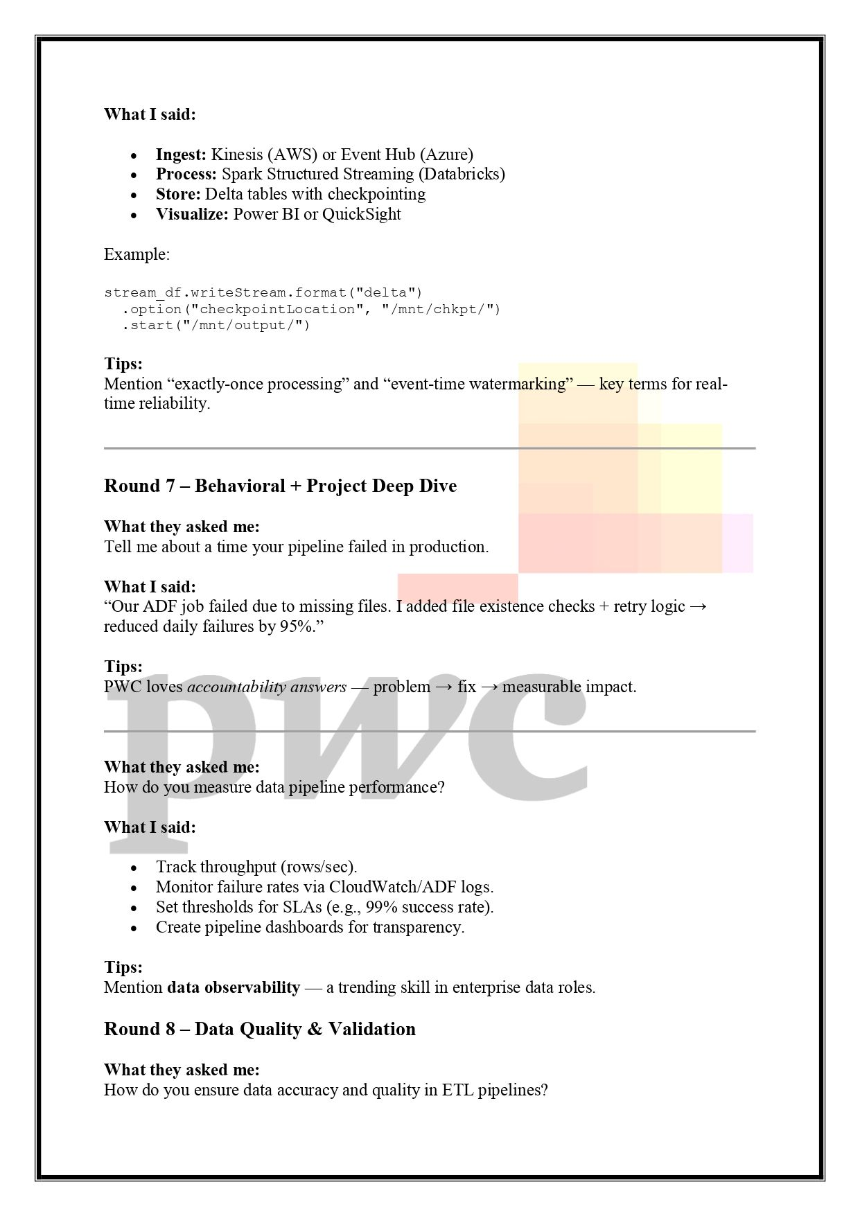

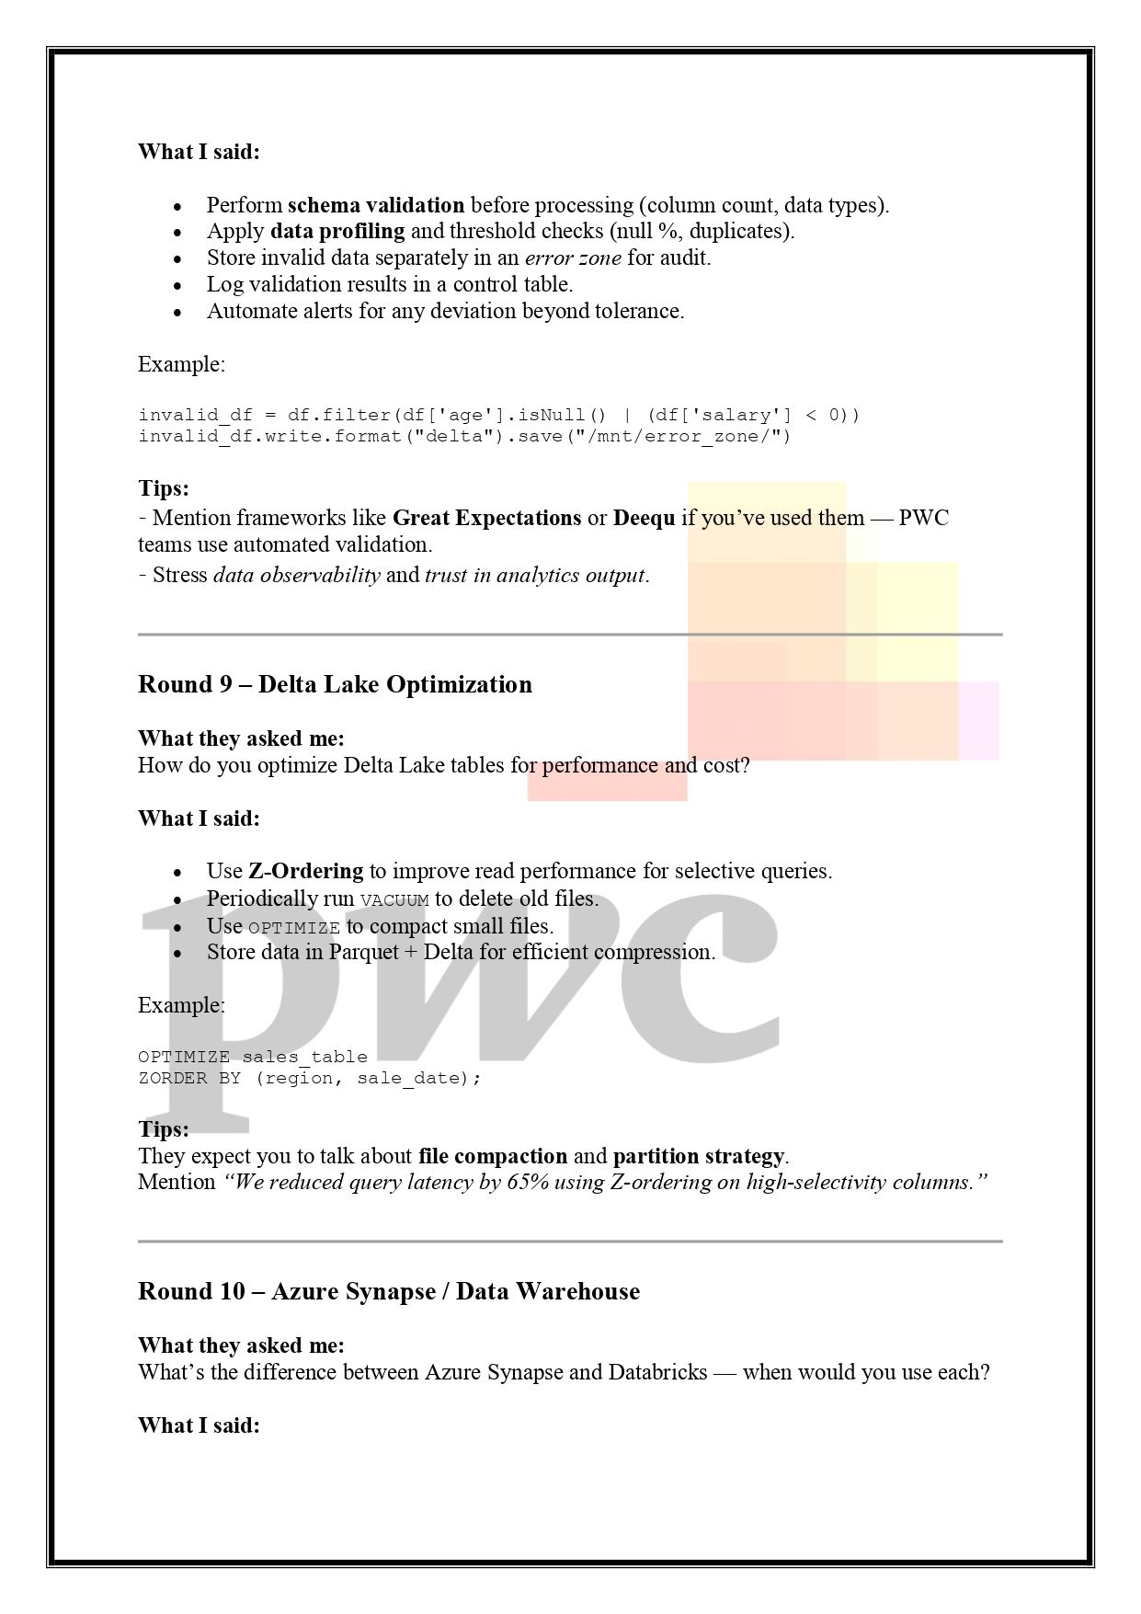

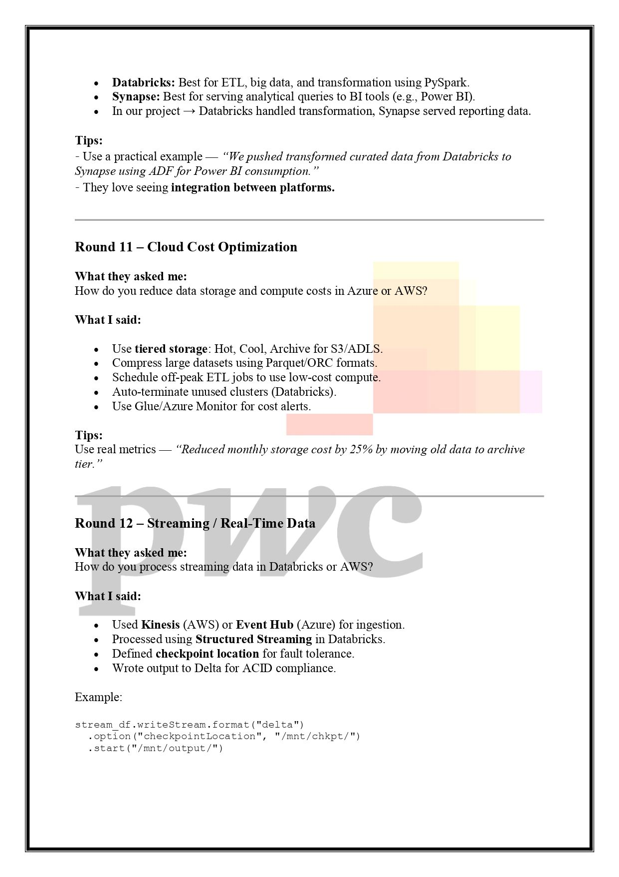

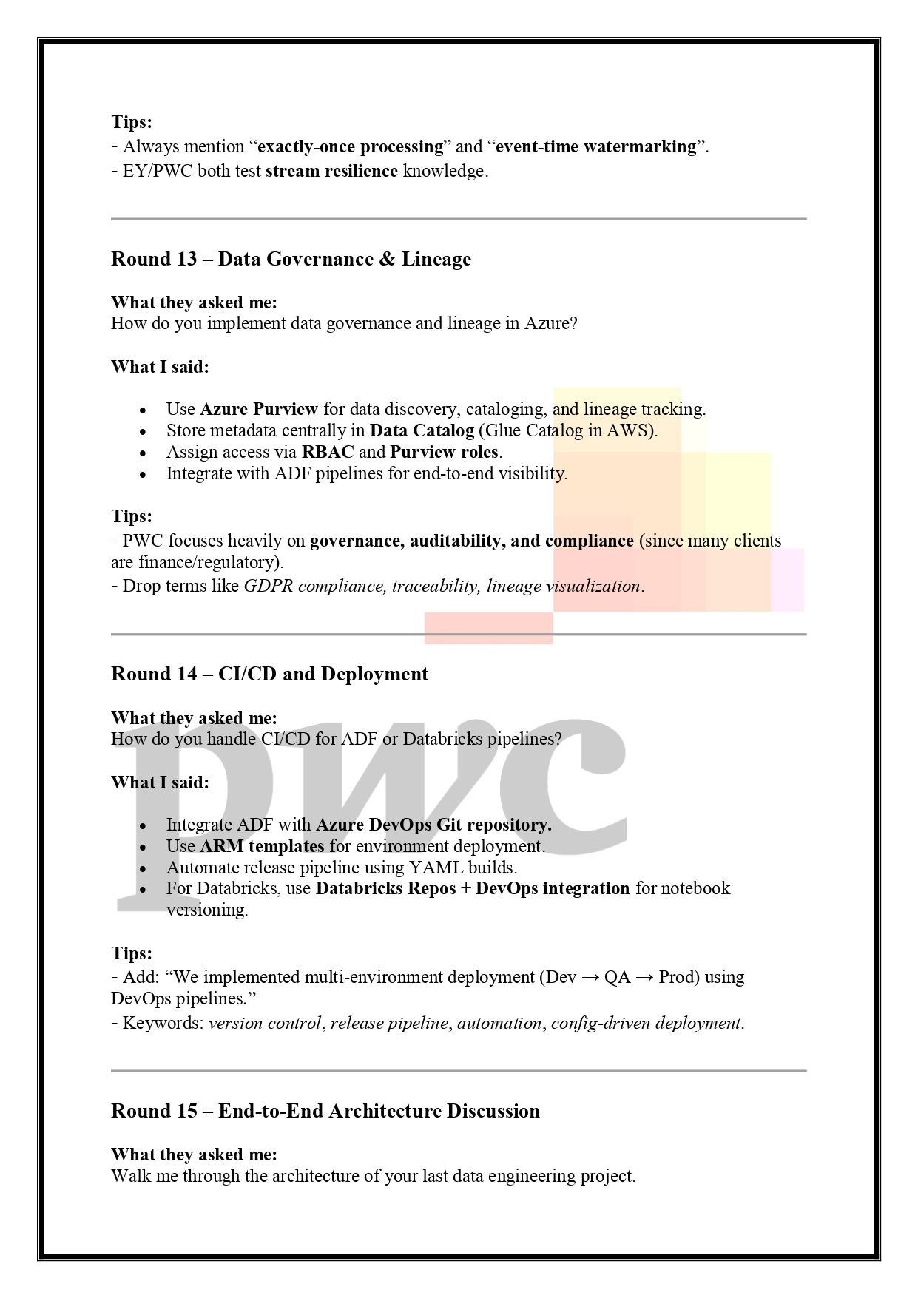

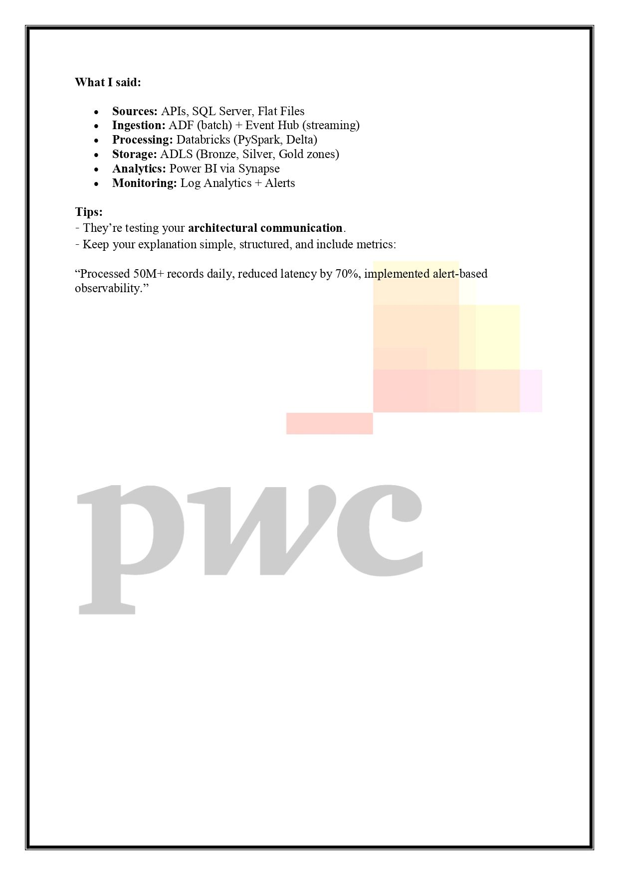

+5
I thought I could never crack an Data Engineering interview Until..
I found this Roadmap.
Here is HOW can you do in 5 steps.
𝗦𝘁𝗲𝗽 𝟭: 𝗦𝗤𝗟
- Basic SQL Syntax
- DDL, DML, DCL
- Joins & Subqueires
- Views & Indexes
- CTEs & Window Functions
𝗦𝘁𝗲𝗽 𝟮: 𝗣𝘆𝘁𝗵𝗼𝗻
- Fundamentals
- Numpy
- Pandas
𝗦𝘁𝗲𝗽 𝟯: 𝗣𝘆𝘀𝗽𝗮𝗿𝗸
- RDD
- Dataframe
- Datasets
- Spark Streaming
- Optimization techniques
𝗦𝘁𝗲𝗽 𝟰: 𝗗𝗮𝘁𝗮 𝗪𝗮𝗿𝗲𝗵𝗼𝘀𝘂𝗶𝗻𝗴/𝗗𝗮𝘁𝗮 𝗠𝗼𝗱𝗲𝗹𝗶𝗻𝗴
- OLAP vs OLTP
- Star & Snowflake Schema
- Fact & Dimension Tables
- Slowly Changing Dimensions (SCD)
𝗦𝘁𝗲𝗽 𝟱: 𝗖𝗹𝗼𝘂𝗱 𝗦𝗲𝗿𝘃𝗶𝗰𝗲𝘀
- Nosql DB
- Relational DB
- Datawarehousing
- Scheduling & Orchestration
- Messaging
- ETL Services
- Storage Services
- Data Processing Services
Free resources to learn these skills.
Azure Data Engineer Roadmap - https://lnkd.in/dCyr4aph
Interview Preparation - https://lnkd.in/gJWSVKNM
SQL - https://lnkd.in/gJXw4XtK
Python - https://lnkd.in/gDrwu4Bx
Pyspark - https://lnkd.in/g7sWrSEU
Data Modeling - https://lnkd.in/gynBBQEh
Azure Cloud - https://lnkd.in/gPU_wSUv
Google Cloud - https://lnkd.in/gn4dMz6Q
AWS Cloud - https://lnkd.in/g8sk4X3w
Mock Interviews - https://lnkd.in/gV_5EFtE
Data Engineering Projects - https://lnkd.in/gZh_t-eK
𝗜 𝗵𝗮𝘃𝗲 𝗽𝗿𝗲𝗽𝗮𝗿𝗲𝗱 𝗖𝗼𝗺𝗽𝗹𝗲𝘁𝗲 𝗜𝗻𝘁𝗲𝗿𝘃𝗶𝗲𝘄 𝗣𝗿𝗲𝗽 𝗚𝘂𝗶𝗱𝗲 𝗳𝗼𝗿 𝗗𝗮𝘁𝗮 𝗘𝗻𝗴𝗶𝗻𝗻𝗲𝗿𝘀.
𝗚𝗲𝘁 𝘁𝗵𝗲 𝗚𝘂𝗶𝗱𝗲 𝗵𝗲𝗿𝗲 - https://lnkd.in/gJWSVKNM
𝗖𝗼𝘂𝗽𝗼𝗻 𝗰𝗼𝗱𝗲 - AZURE50 / AWS50 / GCP50 for next 5 users.

🚨 Data Engineering Interviews Are Changing — Are You Ready?
Cracking interviews today isn’t about memorizing syntax.
It’s about how you think when things break in production.
Top companies are increasingly focusing on real-world problem-solving scenarios instead of theoretical questions.
Here are a few examples you should be comfortable tackling:
🔹 An ETL pipeline fails midway in production — how do you debug efficiently?
🔹 A Spark job processing massive data runs for hours — where do you start optimizing?
🔹 Duplicate records start flooding your system — how do you fix and prevent it?
🔹 Dashboard numbers don’t match expectations — how do you validate data accuracy?
🔹 Source schema changes unexpectedly — how do you design for resilience?
🔹 You need to process 100M+ records daily — what architecture would you choose?
💡 These scenarios reflect day-to-day challenges of a Data Engineer, not textbook problems.
🎯 To stay ahead, focus on building strong fundamentals in:
• SQL Performance Tuning
• PySpark & Distributed Processing
• Data Modeling
• Incremental Loads & CDC
• Data Quality & Validation
• Orchestration (Airflow, ADF)
• Delta Lake & Modern Data Lakes
• Data Warehousing Concepts
• Streaming Pipelines
• Cloud Optimization Strategies
📌 What really makes a difference?
✔ Clear thinking under ambiguity
✔ Ability to break down problems
✔ Understanding trade-offs in design decisions
✔ Communicating solutions effectively
🔥 The takeaway:
Don’t just prepare answers — prepare your approach.
follow Rajeswari Gelasam for more content
hashtag#DataEngineering hashtag#BigData hashtag#PySpark hashtag#SQL hashtag#ETL hashtag#DataPipeline hashtag#Databricks hashtag#Azure hashtag#DataEngineer hashtag#TechCareers hashtag#Cloud hashtag#Analytics hashtag#InterviewPrep hashtag#CareerGrowth

